

Darshan University

A Project Report on

**“Blood Bank Management System”**

Under the subject

**Software Engineering (2101CS503)**

B. Tech, Semester – IV

Computer Science & Engineering Department

|  |  |
| --- | --- |
| Submitted By | |
| Student Name: Mayank Sakariya | Enrollment No.: 23010101234 |
| Academic Year  (2024-2025) | |
| Internal Guide  Prof. Rajkumar Gondaliya  Darshan University | Dean-DIET  Dr. Gopi Sanghani  Darshan University |

|  |  |
| --- | --- |
|  | **Computer Science & Engineering Department**  **Darshan University** |

**DECLARATION**

We hereby declare that the SRS, submitted along with the **Software Engineering** **(2101CS503)** for entitled **“Blood Bank Management System”** submitted in partial fulfilment for the Semester-5 of **Bachelor Technology (B. Tech)** in **Computer Science and Engineering (CSE)** Departmentto Darshan University, Rajkot, is a record of the work carried out at **Darshan University, Rajkot** under the supervision of Prof. Rajkumar Gondaliyaand that no part of any of report has been directly copied from any students’ reports, without providing due reference.

Mayank Sakariya

Student’s Signature

Date: __________

|  |  |
| --- | --- |
|  | **Computer Science & Engineering Department**  **Darshan University** |

**CERTIFICATE**

This is to certify that the SRS on **“Blood Bank Management System” has** been satisfactorily prepared by **Mayank Sakariya (23010101234)** under my guidance in the fulfillment of the course **Software Engineering (2101CS503)** work during the academic year 2023-2024.

|  |  |  |
| --- | --- | --- |
| Internal Guide  Prof. Rajkumar Gondaliya  Darshan University |  | Dean-DIET  Dr. Gopi Sanghani  Darshan University |

**Acknowledgement**

I wish to express my sincere gratitude to my project guide Prof. **Rajkumar Gondaliya** and all the faculty members for helping me through my project by giving me the necessary suggestions and advices along with their valuable co- ordination in completing this work.

I also thank my parents, friends and all the members of the family for their precious support and encouragement which they had provided in completion of my work. In addition to that, I would also like to mention the Darshan University personals who gave me the permission to use and experience the valuable resources required for the project from the University premises.

Thus, in conclusion to the above said, I once again thank the faculties and members of **Darshan University** for their valuable support in completion of the project.

Thanking You

**Mayank Sakariya**

**ABSTRACT**

The Blood Bank Management System is a Software designed to improve how blood bank work. It includes functionalities for donor, recipients, managers, administrators, quality testing, inventory control, and supply logistics.

The system helps donors to register easily and keeps track of their information. It also manages requests from hospitals and clinics for blood. Managers use it to oversee everything and make sure the system runs smoothly. Administrators control who can use the system and keep data safe.

Quality testing checks that blood is safe. Inventory control tracks how much blood is available and when it expires. Supply logistics handle getting blood where it’s needed, quickly and efficiently.

The Blood Bank Management System makes blood bank more efficient and helps ensure that blood donations are used effectively to help patients.

Table of Contents

1.1 Functional Requirement 8

**1.1.1** **Donor** 8

**1.1.2** **Recipients** 8

**1.1.3** **Manager** 8

**1.1.4** **Administrator** 9

**1.1.5** **Laboratory coordinator** 10

**1.1.6** **Inventory Controller** 10

**1.1.7** **Supply Coordinator** 10

1.2 Non-Functional Requirement 10

1.2.1 **Usability**: 10

**1.2.2** **Security** 11

**1.2.3** **Reliability** 11

**1.2.4** **Performance** 11

2 Design and Implementation Constraints 12

2.1 Use case diagram 12

2.2 Activity diagram and Swimlane diagram 13

13

2.3 Sequence diagram 16

2.4 State diagram 17

2.5 Class diagram 18

List of Figures

Figure 2.1-1 Use case diagram for Blood Bank Management System……………………………………………………13

Figure 2.2-1 Activity diagram for Blood donation ………………………………………………………………………………..14

Figure 2.2-2 Activity diagram for Blood Recipients ………………………………………………………………………………15

Figure 2.2-1 Swimlane diagram for Donor …………………………………………………………………………………………..16

Figure 2.2-2 Swimlane diagram for Recipients……………………………………………………………………………………..16

Figure 2.3-1 Sequence diagram for blood donation ………………………..…………………………………………………..9

Figure 2.4-1 State diagram of blood ……………………………………………….…………………………………………………..10

Figure 2.5-1 Class diagram for Blood bank management system ….…………………………………………………….11

Figure 2.6-1 Context diagram for Blood bank management system ……………………………………………………12

Figure 2.6-2 DFD level-1 for Blood Bank management system ……………………………………………………………12

Figure 3.1-1 Screen-1: Registration Form……………………………….……………………………………………………………13

Figure 3.2-1 Screen-2: Blood Donation Campaign Management …………………………………………………………14

Figure 3.3-1 Screen-3: Health Information…………………………………………………………………………………………..15

Figure 3.4-1 Screen-4: Transaction Information………………………………..…………………………………………………16

Figure 3.5-1 Screen-5: Donation Details……………………………………………………………………………………………….17

## Functional Requirement

### **Donor**

* User Registration: Donors can create an account by providing personal information and medical history.
* User Login: Donors can create an account by providing personal information and medical history.
* Update Profile: Donors can update their personal information and medical history.
* View Donation History: Donors can update their personal information and medical history.
* Schedule Donation: Donors can schedule appointments for donating blood.
* Cancel Donation Appointment: Donors can cancel scheduled donation appointments.
* View Eligibility: Donors can check their eligibility to donate based on predefined criteria.
* Receive Notifications: Donors receive notifications for upcoming appointments and reminders for future donations.
* Blood Group Entry: Donors can enter their blood group information.
* Contact Support: Donors can contact support for any assistance or queries.

### **Recipients**

* Request Blood: Recipients can submit requests for specific blood types.
* View Request Status: Recipients can check the status of their blood requests.
* View Donation History: Recipients can view the history of blood received.
* Schedule Pickup: Recipients can schedule a pickup time for the requested blood.
* Cancel Request: Recipients can cancel a blood request if it is no longer needed.
* View Blood Availability: Recipients can view the availability of different blood types in the inventory.
* Receive Notifications: Recipients receive notifications regarding their requests and availability of blood.

### **Manager**

* Manager Login: Managers can log in to their accounts using secure credentials.
* Add New Blood Stock: Managers can add new blood units to the inventory.
* Update Blood Stock: Managers can update the details of existing blood units.
* Delete Blood Stock: Managers can remove outdated or unused blood units from the inventory.
* View Blood Inventory: Managers can view the current inventory of blood units.
* Generate Inventory Report: Managers can generate detailed reports on blood inventory levels.
* Monitor Requests: Managers can monitor blood requests and their statuses.
* Approve/Reject Requests: Managers can approve or reject blood requests based on availability and eligibility.
* Handel User Accounts: Managers can add, update, and delete user accounts for donors and recipients.
* View User Activity: Managers can view logs of user activities and interactions with the system.

### **Administrator**

* Admin Login: Admins can securely log in to access their account and the admin interface.
* System Oversight: Admins oversee the entire system, ensuring smooth and efficient operations.
* Access Control: Admins define and control user roles and permissions, ensuring appropriate access levels for different users.
* Security Settings: Admins configure and update security settings to protect sensitive data and ensure compliance with data privacy regulations.
* Activity Monitoring: Admins monitor system activities through audit logs, detecting and preventing unauthorized access or suspicious activities.
* System Customization: Admins customize system settings to align with the specific needs and workflows of the blood bank.
* Data Backup: Admins perform data backup and recovery operations to ensure critical data preservation and restoration in case of system failure.
* Report Generation: Admins generate comprehensive reports on donors, recipients, inventory, and transactions, providing valuable insights for decision-making.
* Notification Configuration: Admins configure and manage email and SMS notifications to keep stakeholders informed about important updates and reminders.
* Compliance Assurance: Admins ensure that the Blood Bank Management System complies with relevant healthcare regulations and standards, maintaining the system's integrity and trustworthiness.

### **Laboratory coordinator**

* Blood Testing Records: Record the results of tests conducted on blood units for various parameters such as blood type, infections, and compatibility.
* Quality Assurance Reports: Generate detailed reports on the quality testing outcomes, including pass/fail rates, and flag any units that do not meet the required standards.
* Testing Schedule Report: Schedule and track periodic quality testing for stored blood units to ensure ongoing compliance with safety standards.

### **Inventory Controller**

* Real-Time Inventory Tracking: Track the real-time status of blood units, including blood type, quantity, and expiration dates, to maintain accurate inventory levels.
* Inventory Alerts: Set up alerts for low inventory levels or approaching expiration dates to ensure timely replenishment or disposal of blood units.
* Inventory Audits: Perform regular inventory audits to verify stock levels and ensure data accuracy in the inventory system.

### **Supply Coordinator**

* Supply chain Monitoring: Monitor the flow of blood units throughout the supply chain, from donation to distribution, ensuring efficient logistics management.
* Distribution Oversight: Manage the distribution of blood units to hospitals and clinics, tracking delivery schedules and ensuring timely supply.
* Resource Allocation: Allocate resources effectively to manage the supply of blood units, optimizing distribution routes and minimizing wastage.
* **Demand Prediction:** Uses data to forecast future blood supply needs, optimizing logistics and reducing shortages.

## Non-Functional Requirement

### **Usability**:

* The system should have an intuitive and user-friendly interface to facilitate ease of use for all user roles.

### **Security**

* Keep donor and recipient information secure and confidential, allowing access only to authorized personnel.

### **Reliability**

* The system should be reliable, with minimal downtime and the ability to recover data in case of system failures or crashes.

### **Performance**

* The system should be capable of handling a large volume of donor registrations, test results, inventory records, and supply requests without significant performance degradation.
* Receive Notifications: Recipients receive notifications regarding their requests and availability of blood.

# Design and Implementation Constraints

## Use case diagram

Figure ‑ Use case diagram for blood bank Management system

Figure ‑ Use case diagram for blood bank Management system

## Activity diagram and Swimlane diagram

## 

Figure ‑ Activity diagram for Blood Donation

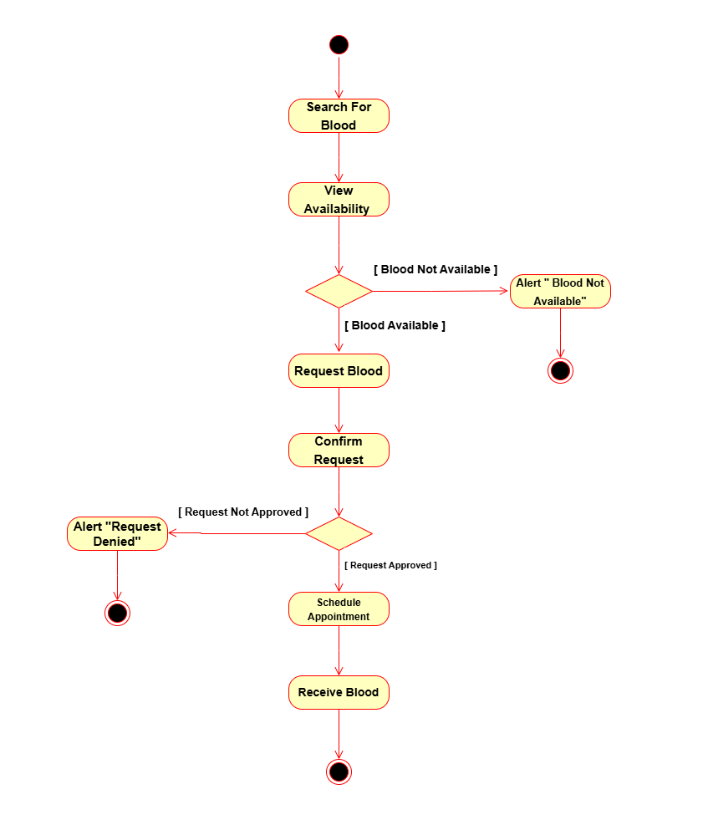

Figure 2.2‑1 Activity diagram for Blood Recipients

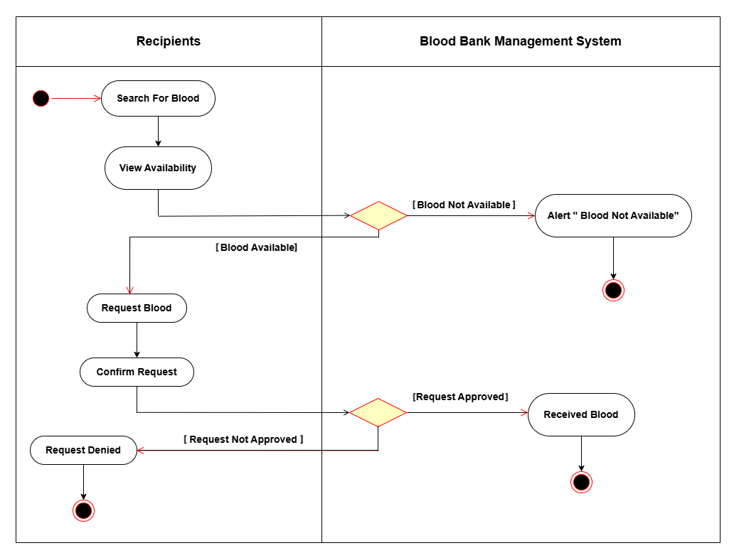

Figure 2.2‑3 Swimlane diagram for Recipient

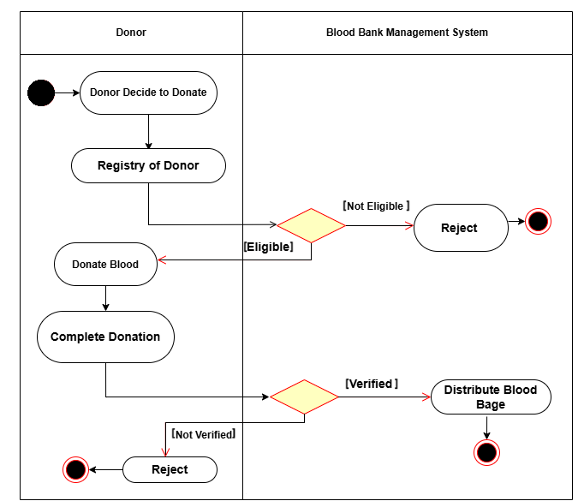

Figure ‑ Swimlane diagram for Donor

## Sequence diagram

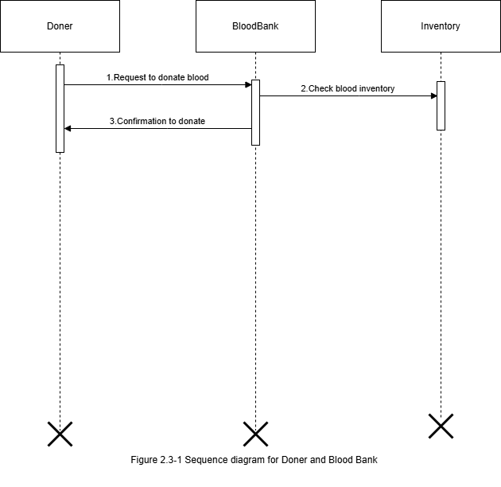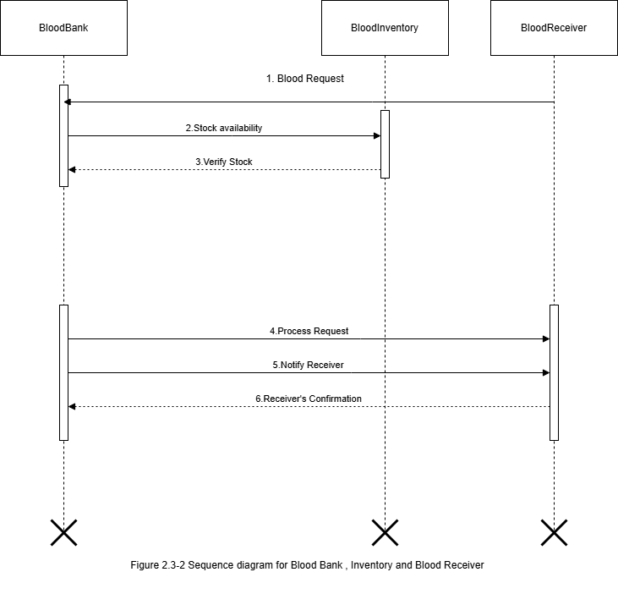

## State diagram

Figure 2.4‑1 State diagram of Blood

2’

## -Class diagram

Figure 2.5‑1 Class diagram for Blood Bank Management System